Role of HDL

Modern digital chip and system design centers on the use of Hardware Description Languages (HDL) to describe the design at the Register Transfer Level (RTL)

RTL specifies all registers (flip-flops) and the combinational logic cells and they connectivity.

Create the design in RTL is much faster and efficient than drawing a schematic
Design depends heavily on use of EDA
- To verify the design by simulation to be sure that your RTL code are consistent and describe in all points the specification requirements.
- To synthetize the RTL design into netlist and schematic
- To transfer the netlist into a physical layout mapped to a technology library

Designs described in HDL are technology-independent, easy to design and debug, and are usually more readable than schematics, particularly for large circuits

Verilog can be used to describe designs at four levels of abstraction:
(i) Algorithmic level (much like c code with if, case and loop statements).
(ii) Register transfer level (RTL uses registers connected by Boolean equations).
(iii) Gate level (interconnected AND, NOR etc.).
(iv) Switch level (the switches are MOS transistors inside gates).
The language also defines constructs that can be used to control the input and output of simulation.

Verilog is used as an input for synthesis programs which will generate a gate-level description (a netlist) for the circuit.
Some Verilog constructs are not synthesizable. Also the way the code is written will greatly effect the size and speed of the synthesized circuit. Most readers will want to synthesize their circuits, so nonsynthe-sizable constructs should be used only for
test benches. These are program modules used to generate I/O needed to
simulate the rest of the design. The words “not synthesizable”will be used for examples and constructs as needed that do not synthesize.

Based on C, originally Cadence proprietary, now an IEEE standard
Quicker to learn read and design than VHDL
Verilog is a powerful and flexible language

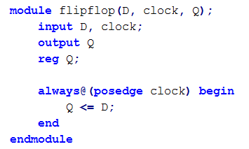
1
2
3
1
4

1: module name, ports listing
2: declarations and parameters list
3: local variables
4: procedural (sequential) block

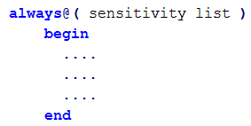
Procedural block

Nota that all variables assigned in procedural code must be of a register data type => reg
The block is executed when triggered event present in always@ statement occurs.
always@(posedge clock) executes whenever a positive edge on the clock
occurs

always@(value)executes whenever any of the statements in parentheses change

Just use always@(*) for combinational logic

An incomplete sensitivity list is a common bug in a design.
Procedure code : blocking and non blocking assignment
What is the difference between the following code segments?
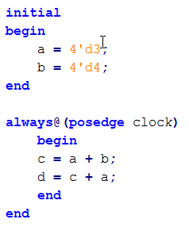
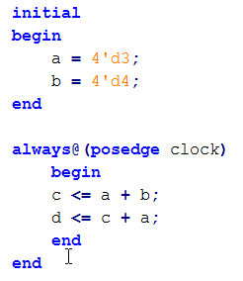

= is referred to as a blocking assignment, because execution of subsequent code is blocked until this statement completes. Essentially, c = a + b; and d = c + a; are performed in series.

<= is referred to as non-blocking assignment. Essentially, c <= a + b; and d <=c+a;
are performed in parallel

Always Use <= when building registers to prevent possible races

Procedural (blocking) assignments (=) are done sequentially in the order the statements are written. A second assignment is not started until the preceding one is complete

RTL (nonblocking) assignments (<=), which follow each other in the code, are started in parallel. The right hand side of nonblocking assignments is evaluated starting from the completion of the last blocking assignment or if none,
the start of the procedure. The transfer to the left hand side is made according to the delays. An intra-assignment
delay in a non-blocking statement will not delay the start
of any subsequent statement blocking or non-blocking.
However a normal delays will are cummulative and will delay the output.

Continuous assignment
Use to build combinational logic
Continuous assignment statements are executed whenever any of the operands on the
right hand side change

Variables being assigned (i.e. on LHS) to must be of a Net data type (e.g. wire, tri)

Variables on RHS of statements can be a Net or Register data types

Statement executes whenever anything on the RHS changes

Flip-flops and latches can NOT be created with continuous assignment
The easiest Verilog coding style is to use procedural code when creating flip-flops and
latches and for complex logic (e.g. Finite State Machines) and use continuous assignment when
specifying small pieces of logic. (Safe to mix the two types in the same module.)

Structural verilog
Complex modules can put together by building (instancing) a number of smaller modules

Module declaration
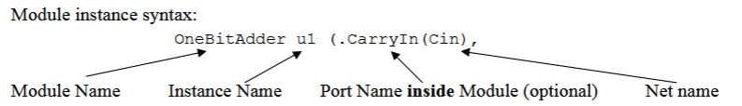

Behavioral Verilog is based on procedural blocks starting with an always or initial statement.

- Code executed in sequence ( unless <= is used ) whenever sensitivity list conditions are satisfied
- assigned variables must be of register type (usually reg)
- flip-flops created with always@(posedge clock) or always@(negedge clock)
- latches created with incomplete if-then or case statements in non-edge-clocked blocks
take care not to inadvertently create unwanted latches.

Continuous assignment creates combinational logic

Structural Verilog is used to put together existing modules

Sequence in Design
Understand Specification
Sketch the design, identifying all registers
Write Verilog
Write test fixture, and debug Verilog
Synthesize, verify, place-and-route, and verify

Procedural code is written like c code

Gate level modeling
implement the basic logic gates => primitives
Two properties can be specified : drives striength and delay

Verilog has four levels of modelling:
1) The switch level which includes MOS transistors modelled as switches. This is not discussed here.
2) The gate level. See “Gate-Level Modelling” on p. 3
3) The Data-Flow level. Utilizes Boolean equations and uses a number of opearators
4) The Behavioral or procedural level described below.

Verilog procedural statements are used to model a design at a higher level of abstraction than the other levels. They
provide powerful ways of doing complex designs. However small changes n coding methods can cause large changes
in the hardware generated. Procedural statements can only be used in procedures. Verilog procedures are described
later in “Procedures: Always and Initial Blocks” on page 18,“Functions” on page 19, and “Tasks, Not Synthesizable”
on page 21

en mode dataflow
module decoder2to4 ( e , a, b, do, dl, d2, d3);
input e, a, b;
output do, dl, d2, d3;
assign dO = ( e & ~a & ~b);
assign dl = (e & ~a & ~b);
assign d2 = (e & a & ~b);
assign d3 = ( e & a & b);
endmodu1e

On the other hand the behavioral modeling in high level description (algorithmic)
Without thinking of the material implementation

module decoder2to4 (e, i, d);
output [3:0] d;
input [l:0]i;
input e;
reg [3:0] d;
always @ (i or e) begin
if (e==l) begin
case (i)
0: d = 4'b 0001;
1: d = 4'b 0010;
2: d = 4'b 0100;
3: d = 4'b 1000;
default d = 4'b xxxx;
endcase
end
else
d = 4'b0000;
end
endmodule

http://www.wiley.com/legacy/wileychi/mblin/supp/student/LN03DataflowlModeling.pdf
RTL (register transfer level) is a combination of dataflow and behavioral modeling

expression = operators + operands

component inference

Latches
A latch is inferred (put into the synthesized circuit) if a variable, or one of its bits, is not assigned in all
branch of an
if statement. A latch is also inferred in a case statement if a variable is assigned to in only some of the branches.
To improve code readability, use the if statement to synthesize a latch because it is difficult to explicitly specify
the latch enable signal using a case statement.
While in theory, a proper reset should be infered from the Verilog code shown, Synopsys will not do a proper job
without adding the //Synopsys comments shown

Cadence-specific Simulation History Manager (SHM) tasks
File to store the waveforms

Standard code style

